CREDIT RISK ANALYSIS USING WEKA IN DATA MINING

Subject: CP3403 – Data Mining
University: James Cook University
Country: Singapore

Prepared By:

Celina Kaesar Lumain 13370770
Mikkel Oerberg Hansen 13574041
Isaac Jia Wei Tan 13567083

Date: September 21 2018

Group No: 22

TABLE OF CONTENTS

I. INTRODUCTION
1.1 DEFINITION OF TASK

II. STRUCTURE OF THE DATA SETS
2.1 DEFINITION OF ATTRIBUTES

III. STRATEGY OF ANALYSIS

IV. DATA PRE-PROCESSING
4.1 DATA PRE-PROCESSING
4.2 DATA OVERVIEW

V. ANALYSIS
5.1 INITIAL TESTING
5.2 CLASSIFIER TWEAKING

VI. CONCLUSION

VII. APPENDIX
7.1 WEKA SCREENSHOTS
INTRODUCTION

The importance of loans in our day-to-day life has increased to greater extent. People are becoming more and more dependent on acquiring loans, whether it could be an educational, housing, car or business loans, etc. from banks and credit unions. However, it is no longer surprising to see that some people are not able to properly gauge the amount of loan that they can afford. In some cases, people undergo sudden financial crisis while some try to scam money out of the banks.

Assessing the risk, which is involved in a loan application, is one of the most important concerns of the banks for survival in the highly competitive market and for profitability. These banks receive number of loan applications from their customers and other people on daily basis. Not everyone gets approved. Most of the banks use their own credit scoring and risk assessment techniques to analyze the loan application and to make decisions on credit approval.

1.1 DEFINITION OF THE TASK

The goal of this project is to be able to predict if a customer has a good or bad credit risk, thereby helping the banks make better loan decisions in the future.

Such data mining techniques will help banks to distinguish between borrowers who pay back loans at the appointed time from those who don’t thus also helps to expect when the borrower is at default, whether providing loan to a particular customer will result in bad loans. All processes related to banking sector could be analyzed using data mining to detect the customers behavior. It can also help to analyze whether the customer will make prompt or delay payment if the credit cards are sold to them.

Later, in the project, the task was modified to predict the customer’s credit history and risk assessment based on the data set that we chose.

II. STRUCTURE OF DATA SET

The data contains 1,000 instances and 21 attributes including the class. Fortunately, there are no missing values or spelling mistakes in the data we chose. The data set can be found at: https://www.openml.org/d/31 under the title credit-g.

A collection of data from banking sector has been selected. The Data set format that is acceptable by Weka is (CSV) which stand for Comma Separated Values CSV which is composed of tags that include the name of attributes, labels, and the data itself.

The data set contains the following attributes:

No | Attribute | Description | Data Type
1 | Checking_Status | Status of existing checking account | Nominal
2 | Duration | Duration in months | Numeric
3 | Credit History | Credit cards taken, paid back duly, delays, critical amounts | Nominal
4 | Purpose of Credit | Car, TV, study loans, furniture | Nominal
5 | Credit Amount |  | Numeric
6 | Savings_Status | Status of savings account or bonds | Nominal
7 | Employment | Present employment, in no. of years | Nominal
8 | Installment_Commitment | Installment rate in percentage of disposable income | Numeric
9 | Personal status | (married, single,...) and sex | Nominal
10 | Other parties | Other debtors / guarantors | Nominal
11 | residence_since | Present residence since X years | Numeric
12 | Property_magnitude | Property e.g real estates | Nominal
13 | Age | In years | Numeric
14 | Other_payment_plans | Bank, stores, none | Nominal
15 | Housing | Rent, own, free | Nominal
16 | Existing_credits | No. of existing credits in the bank | Numeric
17 | Job | Skilled, unskilled, highly qualified, unemployed | Nominal
18 | Num_dependents | No. of People being liable to provide maintenance for | Numeric
19 | Own_Telephone | Yes, no | Nominal
20 | Foreign _Worker | Yes, no | Nominal
21 | Class | Good or bad
Table 1: Data Set Description

This dataset classifies people described by a set of attributes as good or bad credit risks.
This dataset comes with a cost matrix:
Actual/Predicted | Good | Bad
Good | 0 | 1
Bad | 5 | 0

Table 2: Cost Matrix

III. STRATEGY OF ANALYSIS

We have performed the following iterative steps during this study:

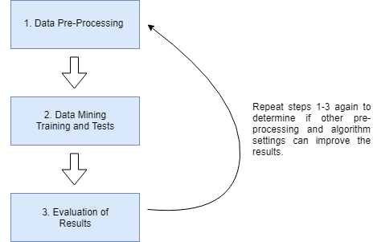
Figure 1: Iterative Steps to For Analyzing the Data

Since the data comes with a cost matrix (as seen on Table 2), we will then put our focus more on the different algorithms with a cost sensitive adaptation.

We will use WEKA to perform our analysis. The cost classifiers can be found under the Classify tab – and “Choose” classifier – select the Meta filter and look for classifier called “CostSensitiveClassifier”.

The cost matrix states that there is a high cost for having false-positive results. This can be seen in context to our business situation wherein it is bad for a bank to loan money to people with bad credit status.

With that in mind, our preferred method of evaluation will be prediction and overall accuracy. Our main objective would be finding a classifier that has a high prediction rate whilst retaining a high accuracy rate.

IV. DATA PRE-PROCESSING

  - DATA PRE-PROCESSING

The first step is to separate the data into two parts: a training set and a test set wherein the class values are representative of the original data set (population). We will then use 90% of the data for training and 10% for testing. We will do the same pre-processing on both data sets

Looking back at the structure of the data (as seen on Table 1), we have 7 numeric attributes where three of these take values 1-4.

Attribute | Values
Installment_Commitment | 1, 2, 3, 4
residence_since | 1, 2, 3, 4
existing_credits | 1, 2, 3, 4
Table 3: Structure of Dataset

While these attributes are considered Numerical in WEKA, it seems that the values are in fact labels covering some sort of value which is unknown to us.

We will therefore use the filter “Numeric to Nominal” on these attributes.

  - DATA OVERVIEW

The table below shows the nominal attributes and how the values are distributed according to the class values.
Description: We can see from the table above, that people with “critical/other existing credit” is very likely to have a good credit rating. We expect this due to the fact that they were already approved once by a bank so they are likely to be approve again.

ATTRIBUTES | LABELS | CLASS = GOOD | % GOOD | CLASS = BAD | % BAD | TOTAL INSTANCES
Checking Status
Checking Status | 0<=X<200 | 142 | 59.66 | 96 | 40.34 | 238
Checking Status | No checking | 318 | 88.83 | 40 | 11.17 | 358
Checking Status | <0 | 127 | 51.00 | 122 | 49.00 | 249
Checking Status | >=200 | 43 | 78.18 | 12 | 21.82 | 55
Checking Status | total | 630 | 70 | 270 | 30 | 900
Description: We can see from the table above, that people with “no checking” or checking status of “>=200” is very likely to have a good credit rating. Meanwhile, it would be hard to figure out credit ratings for people with checking status of “< 0” or “0<=X<200”.

Credit history | Existing paid | 329 | 68.26 | 153 | 31.74 | 482
Credit history | critical/other existing credit | 214 | 82.95 | 44 | 17.05 | 258
Credit history | delayed previously | 54 | 67.50 | 26 | 32.50 | 80
Credit history | no credits/all paid | 13 | 37.14 | 22 | 62.86 | 35
Credit history | all paid | 20 | 44.44 | 25 | 55.56 | 45
Credit history | total | 630 | 70 | 270 | 30 | 900
Purpose | radio/tv | 198 | 78.57 | 54 | 21.43 | 252
Purpose | education | 26 | 55.32 | 21 | 44.68 | 47
Purpose | furniture/equipment | 112 | 69.57 | 49 | 30.43 | 161
Purpose | new car | 126 | 60.00 | 84 | 40.00 | 210
Purpose | used car | 77 | 82.80 | 16 | 17.20 | 93
Purpose | business | 56 | 66.67 | 28 | 33.33 | 84
Purpose | domestic appliance | 7 | 63.64 | 4 | 36.36 | 11
Purpose | repairs | 14 | 63.64 | 8 | 36.36 | 22
Purpose | other | 6 | 54.55 | 5 | 45.45 | 11
Purpose | retraining | 8 | 88.89 | 1 | 11.11 | 9
Purpose | total | 630 | 70 | 270 | 30 | 900
Description: We can see from the table above, that there is a higher percentage of good credit ratings among people with a purpose of purchasing “used car” or “retraining” and “radio/tv”.

Saving Status  Description: We can see from the table above that people with saving status of either “500<=X<1000” or “>=1000” is very likely to have a good credit rating. We can also see that people with “no known savings” have a high percentage of good credit ratings which is a little surprising. | <100 | 348 | 64.33 | 193 | 35.67 | 541
 | no known savings | 133 | 82.10 | 29 | 17.90 | 162
 | 500<=X<1000 | 50 | 83.33 | 10 | 16.67 | 60
 | >=1000 | 34 | 87.18 | 5 | 12.82 | 39
 | 100<=X<500 | 65 | 66.33 | 33 | 33.67 | 98
 | total | 630 | 70.00 | 270 | 30.00 | 900
Employment  Description: We can see from the table above that people with employment “4<=X<7” and “>=7” is very likely to have a good credit rating. | 1<=X<4 | 212 | 69.28 | 94 | 30.72 | 306
 | 4<=X<7 | 121 | 79.08 | 32 | 20.92 | 153
 | >=7 | 167 | 73.89 | 59 | 26.11 | 226
 | unemployed | 35 | 62.50 | 21 | 37.50 | 56
 | <1 | 95 | 59.75 | 64 | 40.25 | 159
 | total | 630 | 70.00 | 270 | 30.00 | 900
Installment Commitment | 1 | 93 | 73.81 | 33 | 26.19 | 126
Installment Commitment | 2 | 149 | 73.40 | 54 | 26.60 | 203
Installment Commitment | 3 | 102 | 71.33 | 41 | 28.67 | 143
Installment Commitment | 4 | 286 | 66.82 | 142 | 33.18 | 428
Installment Commitment | total | 630 | 70.00 | 270 | 30.00 | 900
 |  | Description: We can see from the table above that none of the installment commitments labels are especially more likely to give a good credit rating than the others.
Personal Status | female div/dep/mar | 180 | 64.98 | 97 | 35.02 | 277
Personal Status | male single | 363 | 73.63 | 130 | 26.37 | 493
Personal Status | male div/sep | 27 | 58.70 | 19 | 41.30 | 46
Personal Status | male mar/wid | 60 | 71.43 | 24 | 28.57 | 84
Personal Status | total | 630 | 70.00 | 270 | 30.00 | 900
Description: We can see from the table above that single males (“male single”) have a higher percentage of good credit ratings.

Other Parties | none | 571 | 69.55 | 250 | 30.45 | 821
Other Parties | guarantor | 37 | 88.10 | 5 | 11.90 | 42
Other Parties | co applicant | 22 | 59.46 | 15 | 40.54 | 37
Other Parties | total | 630 | 70.00 | 270 | 30.00 | 900
Description: We can see from the table above that if there is a “guarantor”, the customer would very much likely have a good credit rating.

Residence Since | 1 | 84 | 70.59 | 35 | 29.41 | 119
Residence Since | 2 | 187 | 68.75 | 85 | 31.25 | 272
Residence Since | 3 | 93 | 69.92 | 40 | 30.08 | 133
Residence Since | 4 | 266 | 70.74 | 110 | 29.26 | 376
Residence Since | total | 630 | 70.00 | 270 | 30.00 | 900
Property Magnitude  Description: We can see from the table above that owning a real estate makes it more likely to have a good credit rating. | real estate  Description: We can see from the table above that none of the Residence_Since labels are especially more likely to give a good credit rating than the others. | 197 | 77.56 | 57 | 22.44 | 254
 | life insurance | 148 | 71.50 | 59 | 28.50 | 207
 | no known property | 79 | 55.63 | 63 | 44.37 | 142
 | car | 206 | 69.36 | 91 | 30.64 | 297
 | total | 630 | 70.00 | 270 | 30.00 | 900
 | none | 533 | 72.62 | 201 | 27.38 | 734
Other Payment Plans | bank | 73 | 58.87 | 51 | 41.13 | 124
 | stores | 24 | 57.14 | 18 | 42.86 | 42
 | total | 630 | 70.00 | 270 | 30.00 | 900
 | Description: We can see from the table above that having “none” other payment plans is the most likely way to have a good credit rating.
 | own | 471 | 73.94 | 166 | 26.06 | 637
Housing | for free | 58 | 57.43 | 43 | 42.57 | 101
 | rent | 101 | 62.35 | 61 | 37.65 | 162
Description: We can see from the table above that to “own” a property would is the most likely way to have a good credit rating. | total | 630 | 70.00 | 270 | 30.00 | 900
Existing Credits | 1 | 392 | 68.89 | 177 | 31.11 | 569
Existing Credits | 2 | 217 | 71.62 | 86 | 28.38 | 303
Existing Credits | 3 | 17 | 77.27 | 5 | 22.73 | 22
Existing Credits | 4 | 4 | 66.67 | 2 | 33.33 | 6
Existing Credits | total | 630 | 70.00 | 270 | 30.00 | 900
Description: We can see from the table above that the label “3” gives the highest percentage of good credit rating.

Job | skilled | 405 | 71.05 | 165 | 28.95 | 570
Job | unskilled resident | 128 | 71.11 | 52 | 28.89 | 180
Job | high qualif/self emp/mgmt | 86 | 65.15 | 46 | 34.85 | 132
Job | unemployed/unskilled non res | 11 | 61.11 | 7 | 38.89 | 18
Job | total | 630 | 70.00 | 270 | 30.00 | 900
Own Telephone | none | 373 | 68.95 | 168 | 31.05 | 541
Own Telephone | yes | 257 | 71.59 | 102 | 28.41 | 359
Own Telephone | total | 630 | 70.00 | 270 | 30.00 | 900
Foreign Worker | yes | 601 | 69.24 | 267 | 30.76 | 868
Foreign Worker | no | 29 | 90.63 | 3 | 9.38 | 32
Foreign Worker | total | 630 | 70.00 | 270 | 30.00 | 900
Description: We can see from the table above that there is a high percentage of people with good credit ratings amongst the people with job labels of “skilled” and “unskilled resident” .

Description: We can see from the table above that the table does not affect the credit ratings. Though having a telephone does have the highest probability of good credit rating.

Description: We can see from the table above that being a foreign worker is very different from a non-foreign worker. Foreign workers have a lower percentage of good credit ratings whilst non-foreign workers have a stunning 90% good credit ratings.

Table 4: Nominal Attribute Overview of the Training Data Set

Meanwhile, the distribution of the numeric attributes are provided in the table below:
Duration Numeric |  | Max | Min | Mean | StdDev
Duration Numeric | Summary | 72 | 4 | 20.903 | 12.029
Credit Amount Numeric |  | Max | Min | Mean | StdDev
Credit Amount Numeric | Summary | 18424 | 250 | 3259.851 | 2841.545
Age Numeric |  | Max | Min | Mean | StdDev
Age Numeric | Summary | 75 | 19 | 35.472 | 11.436
Num_Dependents |  | Max | Min | Mean | StdDev
Num_Dependents | Summary | 2 | 1 | 1.157 | 0.364
Table 5: Numeric Attributes

V. ANALYSIS

5.1 INITIAL TESTING

The table below shows the results of testing different algorithms on the test set after building the model on the training data. All algorithms are tested with their default settings.
Table 6: Results of our testing amongst the classifiers
Classifier Name | Accuracy | Sensitivity | Specificity | Precision | Negative Predicted Value (NPR) | False Positive Rate | Error Rate
ZeroR | 30 | 0 | 100 | N/A | 30 | 0 | 70
OneR | 42 | 27.14 | 76.67 | 73.08 | 31.08 | 23.33 | 58
Part | 67 | 70 | 60 | 80.33 | 46.15 | 40 | 33
Jrip | 60 | 52.86 | 76.67 | 84.09 | 41.07 | 23.33 | 40
Decision Table | 51 | 40 | 76.67 | 80 | 35.38 | 23.33 | 49
J48 | 55 | 54.29 | 56.67 | 74.51 | 34.69 | 43.33 | 55
Hoeffding Tree | 71 | 68.57 | 76.67 | 87.27 | 51.11 | 23.33 | 29
DecisionStump | 54 | 42.86 | 80 | 83.33 | 37.5 | 20 | 46
LMT | 62.63 | 64.29 | 58.62 | 78.95 | 40.48 | 41.38 | 37.37
RandomForest | 69 | 68.57 | 70 | 84.21 | 48.84 | 30 | 31
RandomTree | 69.31 | 81.43 | 41.94 | 76 | 50 | 58.06 | 30.69
REPTree | 62 | 51.43 | 86.67 | 90 | 43.33 | 13.33 | 38
Kstar | 61 | 60 | 63.33 | 79.25 | 40.43 | 36.67 | 39
IBK (k=1) | 75 | 88.57 | 43.33 | 78.48 | 61.9 | 56.67 | 25
LWL | 54 | 42.86 | 80 | 83.33 | 37.5 | 20 | 46
Logistic | 65 | 61.43 | 73.33 | 84.31 | 44.9 | 26.67 | 35
Multilayer Perceptron | 77 | 87.14 | 53.33 | 81.33 | 64 | 46.67 | 23
SGD | 63 | 58.57 | 73.33 | 83.67 | 43.14 | 26.67 | 37
SimpleLogistic | 58 | 50 | 76.67 | 83.33 | 39.66 | 23.33 | 42
SMO | 63 | 60 | 70 | 82.35 | 42.86 | 30 | 37
BayesNet | 63 | 58.57 | 73.33 | 83.67 | 43.14 | 26.67 | 37
NaiveBayes | 71 | 68.57 | 76.67 | 87.27 | 51.11 | 23.33 | 29

Based on the table shown above, we can see that the classifier with the highest precision is the REPTree (see blue highlights). Though it has a high precision, an accuracy of 62 is not high enough to be amongst our favorite candidates.

The table above also shows that the classifier with the highest accuracy is Multilayer Perceptron (see green highlights) but it only has a precision score of 81 which is not good either. Meanwhile, the next highest accuracy would be IBK (k=1) which has an even lower precision score of 78.48 cannot be considered as good either.

The classifiers with the second highest precision would be Naïve Bayes and Hoeffding Tree algorithms which have a precision of 87.27. Both algorithms show that they share the same results and have an accuracy of 71. We will then consider these to be our top candidates since they have the best trade off between a high precision score and a high accuracy score. (see red highlights).
5.2 CLASSIFIER TWEAKING

While having found our selected two candidates, we will then proceed to see if their performance can be improved:

First, we tried changing the settings of the classifiers. Unfortunately, no settings have improved the results but only made it worse. Therefore, we conclude that the default settings for both classifiers were the best to analyze this data set.

Next, we tried different pre-processing of the data set. Since the data contains four numerical attributes, we tried to discretize these. Again, the results only became worse. We also tried to remove all preprocessing of the data, so we instead worked with the default data set. But this setup did not improve the results either.

In conclusion, our initial pre-processing set-up was the best choice.

We also tried removing some attributes. We used WEKA’s select attributes function to find the most important attributes which resulted in four attributes to work with.

These attributes are:
- Checking_status
- Duration
- Credit_history
- Credit_amount

Building the models only using these four attributes only gave us worse results than our initial tests.

Since we were unable to tweak the classifiers to provide us better results, we must therefore conclude that the best way to analyze this type of data set would be using our initial pre-processing set up with all attributes by using either Hoeffding Tree algorithm or Naïve Bayes.
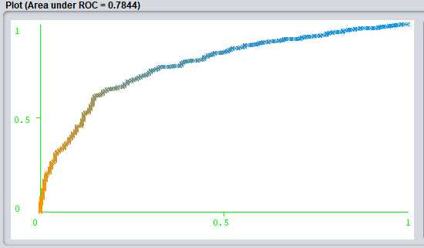

Figure 2: ROC Curve

The ROC curve shows (as seen on Figure 2) that the classifiers have a good performance with a high area under the curve of 0.7844.

VI. CONCLUSION

Based on our analysis, we found two algorithms that have good performance.

They have a high precision which helps the bank eliminate the risk of giving out loans to people with bad credit ratings. At the same time, they showed a decent accuracy which will help the bank not denying costumers a loan based on a false-negative classification of their credit rating.

Having a model like this would help the bank to speed up the process of evaluating customers for a loan. The banks interest is to minimize the risk of giving out loans to people with bad credit ratings, while still staying competitive in the banking industry. This means that it is also important for the bank not to lose to many potential customers by denying them a loan which will send the customer to a different bank.

Working with a model like this in the bank would be an on-going process, so we would expect that the results will be improved, when the bank obtains additional data, to be used in the training of the model.

VII. APPENDIX

7.1 WEKA SCREENSHOT
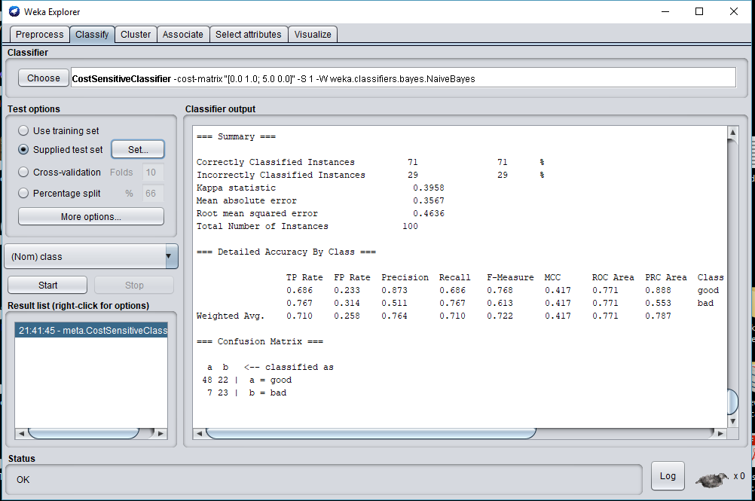

Figure 3: Naive Bayes Performance Result on Weka
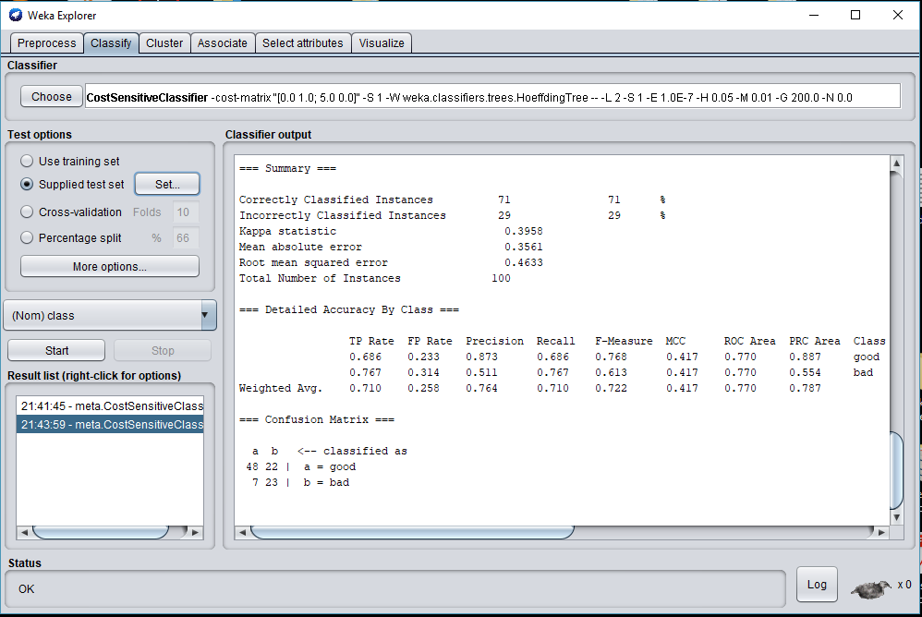

Figure 4: Hoeffding Tree Performance Result on Weka

